

# **Avenue City Elementary School**

18069 Highway 169

Cosby, Missouri 64436

Phone: (816) 662-2305 Fax: (816) 662-3201

Superintendent Becky Grimes Principal Chase Holcumbrink

[bgrimes@avenuecityschool.org](mailto:bgrimes@avenuecityschool.org) [cholcumbrink@avenuecityschool.org](mailto:cholcumbrink@avenuecityschool.org)

www.avenuecityschool.org

Date: August 2024

To: Parents/Guardians

As we begin the school year, we also continue parts of the construction project. Construction staging and traffic will again require our parking and pick-up procedures to change. Please see the attached map for a visual of the procedures. The procedures from last year will be much like last year. Staff parking will be in the parking lot south of the building. Pre-school parents will still park at the west end of the parking lot that is south of the building. The parking lot to the west of the building will be for construction staging and traffic.

As in previous years, parents who are picking up their students must form a line with their cars pointing from West to East directly parallel to the front sidewalk. If your car is not in the appropriate line, your student will be held in the grass north of the sidewalk until the parking lot is clear of buses and other moving vehicles. This is for the safety and expediency of our process. To compensate for the large number of car riders, this year we will again be having a **double line of waiting cars on the south side of the south of the building parking lot**. The two lines will zipper merge into one line **at the turn**. Parents/guardians will still pick their students up at the east end of the parking lot and exit out the east exit.

**Dismissal**:The bell will ring at 3:15 PM. If your child is to go anywhere other than their regular destination, you must send a note stating the appropriate destination. Your child will be sent to their regular destination unless we have a note from you stating otherwise. We will not hold buses or make phone calls to inquire about a student’s destination. Please do not wait and call school at dismissal time and ask us to hold your child at school or ask that we tell them to go to a different destination. The office and classrooms become very busy at the end of the day. It is sometimes impossible to get a message to your child and waiting to inform your child of their destination often leads to added confusion for your child as well as staff members.

Preschool students will be dismissed at 3:10 PM at the south door by the office. Their parents will leave their cars and walk to the door to pick up their child(ren). If you have older students, please park in the pickup line and retrieve them through that process.

If you need to sign your child out for an appointment, please sign them out and leave the parking lot before 3:05 PM. Reminder – any time your child leaves school between the hours of 8:20 AM and 3:15 PM attendance time is deducted.

**Drop Off**: Bus drop off will be on the West side of the building. Students dropped off by parents will be at the front door. Please pull all the way forward to the end of the sidewalk and let students out of the vehicle if it is stopped past the light pole.

The safety and security of all ACES children is always a priority! Thank you for your cooperation!

Chase Holcumbrink

ACES Principal

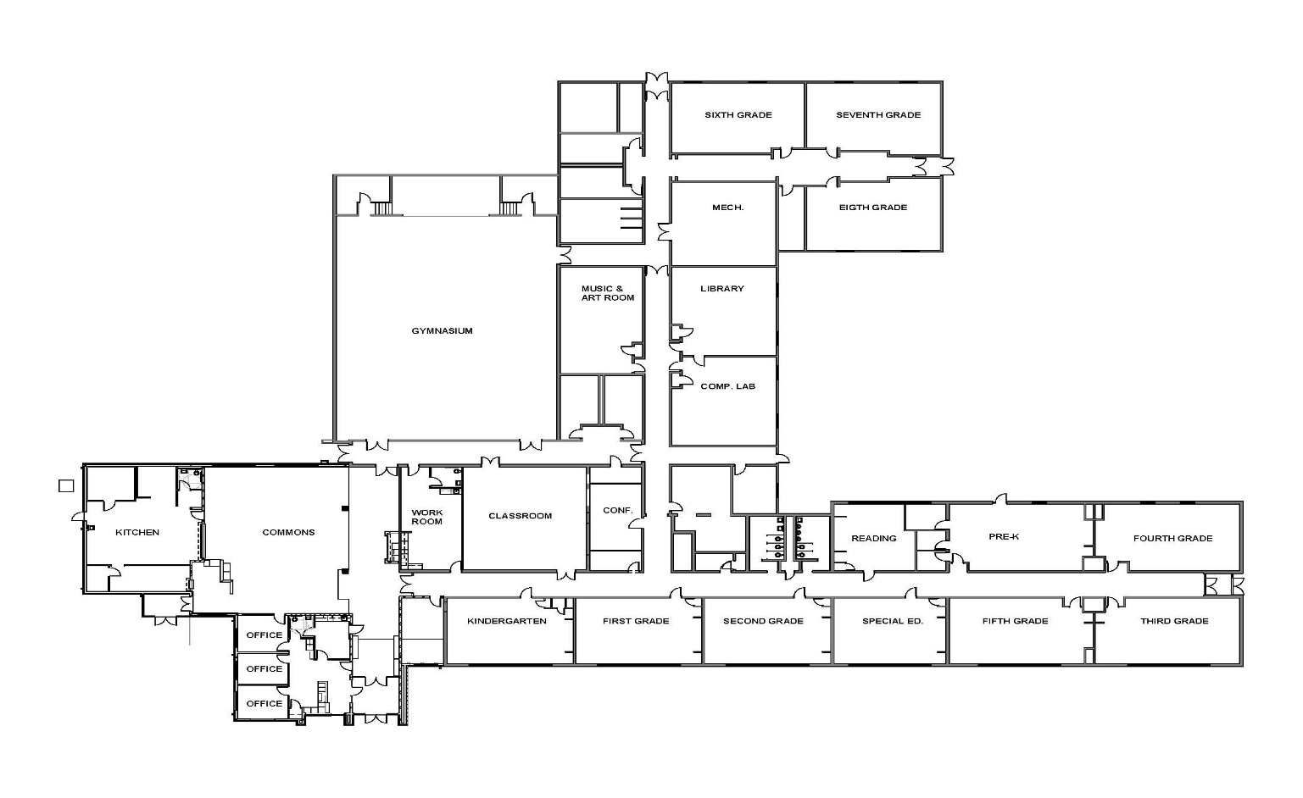

PM Car Riders Exit Here

AM Car Riders

Start Drop Off at Light Pole

**PM Car Riders Load Here!**

**Bus**

**Bus**

No Parking

No Parking

No Parking

No Parking

Bus Riders

Enter & Exit here

Staff Parking Staff Parking

Staff Parking Staff Parking

Preschool Parent Parking

Preschool Parent Parking

Merge

West

Drive

Busses

Enter & Exit here

East

Drive

Cars enter & exit here